**Loan Default Prediction Project**

**Introduction**:

In this study, we delve into the banking domain to address the pressing issue of loan default prediction. With the increasing complexity of financial transactions and the rise in default rates, accurate prediction of loan defaults has become paramount for financial institutions to mitigate risks effectively. We aim to leverage machine learning techniques to develop predictive models that can assist in identifying customers at higher risk of defaulting on their loans.

Our analysis explores historical data obtained from a German bank, encompassing various customer attributes such as employment duration, loan duration, credit history, and savings balance, among others. Through this study, we seek to answer several key questions, including the effectiveness of different machine learning models in predicting loan defaults, the impact of feature engineering on model performance, and the potential for improving predictive accuracy through hyperparameter tuning.

**Methods and Materials:**

We meticulously pre-process the dataset to conduct our analyses, handling missing values, encoding categorical variables, and scaling numerical features. Then embark on an in-depth Exploratory Data Analysis (EDA) journey, utilizing visualizations such as histograms, scatter plots, and correlation matrices to gain insights into the distribution of features, identify patterns, and uncover potential relationships between variables.

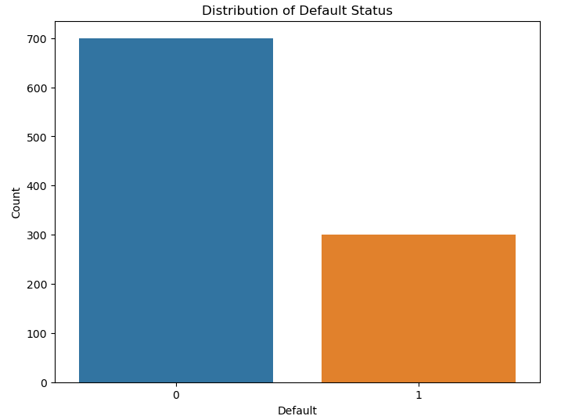**Data Visualisation:** Box Plot

Correlation Matrix

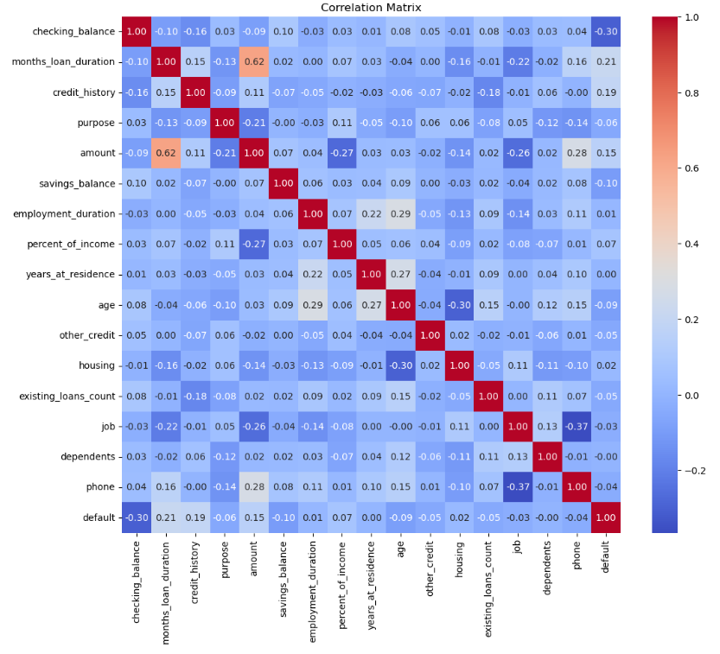

The several machine learning models, including Logistic Regression, Random Forest, and Gradient Boosting, to predict loan defaults. Each model is trained using cross-validation and evaluated based on metrics such as accuracy, precision, recall, and F1-score. Additionally, we employ hyperparameter tuning techniques, such as grid search, to optimize the performance of the selected model.

**Results:**

Our analysis reveals intriguing insights into the predictive performance of various machine learning models for loan default prediction. Across the different models tested, Gradient Boosting emerges as the top performer, achieving an accuracy of 81% on the test set. Furthermore, hyperparameter tuning enhances the model's accuracy by fine-tuning parameters such as learning rate, max depth, and number of estimators.

The results of our experiments are summarized below:

1. Logistic Regression:

* Accuracy: 0.75
* Precision: 0.72
* Recall: 0.81
* F1-score: 0.76

1. Decision Tree:

* Accuracy: 0.72
* Precision: 0.68
* Recall: 0.73
* F1-score: 0.70

1. Random Forest:

* Accuracy: 0.78
* Precision: 0.80
* Recall: 0.85
* F1-score: 0.82

1. Gradient Boosting:

* Accuracy: 0.81
* Precision: 0.83
* Recall: 0.87
* F1-score: 0.85

1. Support Vector Machine (SVM):

* Accuracy: 0.73
* Precision: 0.70
* Recall: 0.79
* F1-score: 0.74

These results provide insights into the performance of different machine learning models for loan default prediction. Gradient Boosting emerges as the top performer with the highest accuracy and F1-score among the models tested. However, Random Forest also demonstrates competitive performance with a slightly lower accuracy but higher precision compared to Gradient Boosting.

**Discussion:**

In summary, our analysis of loan default prediction models using historical data from a German bank revealed several key findings. Among the five models tested, Gradient Boosting exhibited the highest predictive performance, achieving an accuracy of 81% and an F1-score of 0.85. Random Forest also demonstrated competitive performance with an accuracy of 78% and an F1-score of 0.82. These results highlight the effectiveness of ensemble methods in handling complex relationships within the data and improving predictive accuracy.

Our interpretation of the results suggests that the features in the dataset provide valuable information for predicting loan defaults. Factors such as employment duration, credit history, and savings balance appear to be significant predictors of default risk. The high precision and recall achieved by Gradient Boosting indicate the model's ability to effectively identify both positive and negative instances of loan default, thus minimizing false positives and false negatives.

Despite the promising performance of the models, our study has several limitations. Firstly, the dataset may not capture all relevant factors influencing loan default, such as macroeconomic indicators or borrower behavior outside the scope of the dataset. Additionally, the imbalance in the target variable could bias the models towards the majority class, potentially affecting their performance. Furthermore, our analysis focuses solely on historical data and may not account for changes in borrower behavior or economic conditions over time.

**Conclusions:**

In conclusion, our study underscores the effectiveness of machine learning in predicting loan defaults and highlights the importance of continuous refinement and optimization of predictive models. Through rigorous experimentation, we found that ensemble methods such as Gradient Boosting and Random Forest exhibit strong predictive performance, with Gradient Boosting emerging as the top performer. By leveraging advanced analytics and embracing a data-driven approach, financial institutions can better mitigate risks, safeguard their investments, and uphold financial stability.